How to sign up your child for Acro class

Step 1: If you haven’t already, create an account for yourself, the parent, on Energy’s MindBody site. From your computer, go to our site and click Create account in the upper right: https://clients.mindbodyonline.com/classic/ws?studioid=40281&stype=-98

Step 2: After you create an account, you'll need to add your child as a Family Member:
- Click on the My Info tab.
- On your Profile, click on Add Family Member
- Enter the child’s name
- Select the relationship
- Choose Yes besides Pay for by [your name]. This is necessary for the booking to work properly.
- Click Save
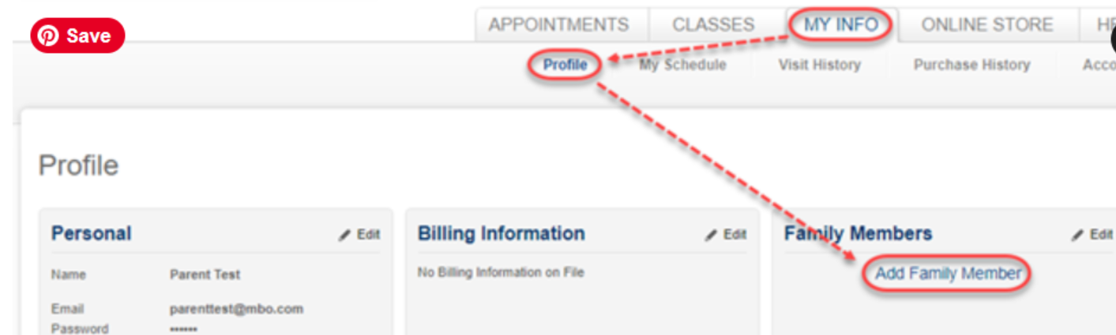
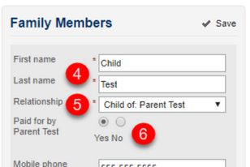

Step 3: After your child is added, you're ready to book him or her in class. (You only need to do the previous steps one time, moving forward you can log in and book classes for your child).
- Go to the Classes tab and find the next Acro class
- Click the Sign Up Now! button
- Click the Make a single reservation – [child’s name] button
- You will then be prompted for payment if you haven't previously purchased sessions. After applying payment, your child is booked in class.
- 